Final Project Report

Moxin Xu
Beijing Foreign Studies University
March 8, 2019

Content

1. Introduction 3
2. Preparation 4
3. Process 5
4. Problems 7
5. Reflection 8

Introduction
When asked the result of one added to one, the kids would stare at their ten stout fingers for a few seconds and then murmur the answer. When asked one hundred and one hundred, not to mention one thousand or more, even counting their toes in, they couldn’t figure it out because its scale is out of their knowledge. As the plight to the kids, how to deal with mass data also puzzles people. For example, it’s easy to download and install Wechat client software in one personal computer, but what if the same process needs to be done in three hundred computers. Using the traditional method would be low-efficient and arduous. However, the recent year has witnessed the rapid development in the field of big data, which offers a solution to the problem.
Thanks to the contribution of numerous experts, big data family now consists of many useful and accessible tools covering every corner from data capture, storage, analysis to sharing, visualization and so on. For instance, Apache Spark is a unified analytic engine for big data processing, powering a stack of libraries. With it, people could easily calculate the approximation of PI, or the occurrence frequency of a certain word in a passage. Docker, cassandra, flask and tensorflow are mainly applied in the project, which would be explained in detail in the preparation section.
The purpose of the project is to identify the number in a hand-written picture posted by a user. Including the name of the picture, predicted number and the time, the result would be sent to the user with the form of a table. Furthermore, the program is running in a container rather than local device, which saves the storage space and promotes portability. The interaction between the users and the interface is also monitored and recorded. The project applies some tools and knowledge in the big data field.
In the recent years, machine learning and artificial intelligence have been heatedly discussed. Huge quantities of movies and TV series, focusing on the topic, have been cast on the screen and widely welcomed by people of all ages. In the season one of Western World, the robots could distinguish tomatoes from apples and identify words in papers. Therefore, the identification of number in the project is similar to the above function, specifically a miniature. Mnist from tensorflow is used to realize the function.

Preparation
In the following, I will introduce my preparation for the project. Some steps could be adjusted according to different operation system or version compatibility.
First, installing ubuntu 16.04 or other Linux operation system to the host computer. Since I bought my first personal computer before entering the college, I have been using Windows operation system as the shop assistant already installed it for me. What’s more, I used to think that compared to Linux, Windows is more user-friendly, offering instant click download soft wares and clear UI. What’s more, I thought sending commands from the terminal was unnecessary because operating with my mouse was more convenient. However, after I installed ubuntu to my computer and adapted to using it, I find its advantages over Windows. Installing python in ubuntu only takes several command lines and starting it only needs a word, spyder. Furthermore, I could open as many terminals as I want, so I could do the thress things,programming, running the programs in the container and uploading file at the same time. Multitasking is very attractive. Therefore, the whole day I spent installing ubuntu is quite worthwhile.
Second, equip ubuntu with docker and create a container with Dockerfile.txt, requirements.txt and app.py. During the process, I created my first container friendlyhello with the instruction from the official website and was amazed at visiting the website page run by the container, greeted by “Hello World!”, which is the first sentence I learned to print out with C language.
Third, use mnist codes to establish the model for identifying number and test it in local device. I spent a lot of finding the illustrated codes, understanding how it works and solving all the errors popped up every time the codes are running. Later, the files need to be copied to your container, so it’s very important to know the meaning of every line, the usage of functions and variables.
Forth, create cassandra container and transplant the intact codes to the base container. I learned data base and SQL last term. Though some instructions are overlapping such as select and insert, cassandra bases on NOSQL, conforming the CAP principle instead of ACID. Tables are established and saved under key spaces. Cassandra container would be later linked by the base container, the one running the codes. Therefore, the result could be sent by the base container to the cassandra container. In addition, the file named mnist_deep.py needs to be run in advance because it aims to download the training instances and save the model.

Process
In the following, the process of operating the computer to realize the goal of the project is illustrated and explained.
First, use the command: docker images
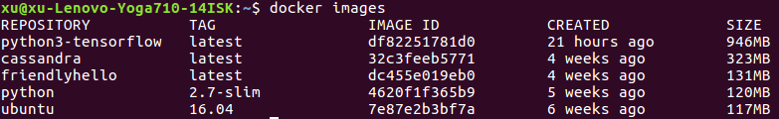
Python3-tensorflow is the base image.
Cassandra is the image to show the result table.
Second, run both the images and link them with the commands:
docker run --name xu-cassandra -p 9042:9042 -d cassandra
docker run -it --name python3-tensorflow --link xu-cassandra:cassandra -p 4000:80 python3-tensorflow
Third, enter the pyhton3-tensorflow container and run the app.py in the saved directory.
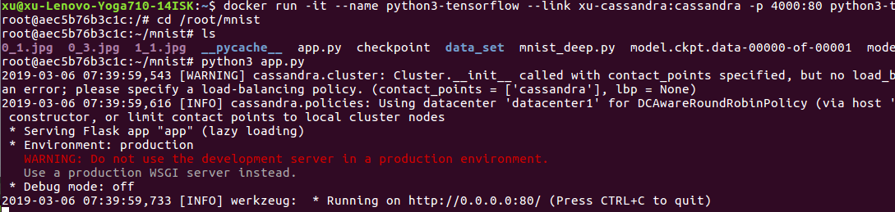
Then the program is running.
Fourth, upload a picture from local directory.
The command: curl localhost:4000/upload -F “file=@name”
The the connecting information would be shown in the base container.
Another command could also enter the container:
sudo docker exec -it container ID bash
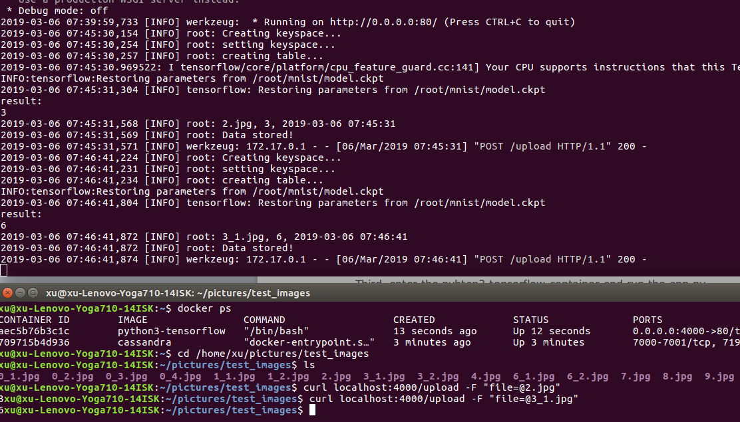
Fifth, start cassandra container and check the table using the commands: docker start xu-cassandra
docker exec -it xu-cassandra cqlsh
In the cqlsh:
use xukeyspace;
Select * from xutable;
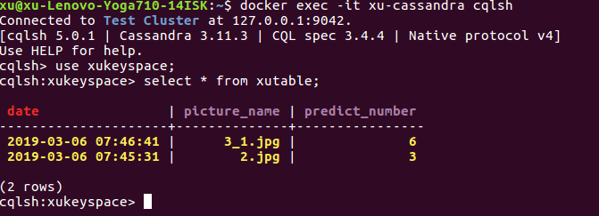
Then the result is shown, including the time, picture’s name and predicted number.
Finally, shut down the whole process. Use ctrl+c to leave the running program and exit to leave the container.

The codes are shown in the following website:
https://github.com/MoxinXu/mnist

Problems
During the project, I’ve confronted countless problems and difficulties. Some have already been solved, while some still exits and others are lurking in somewhere.
Firstly, as is shown at the end of the process section, the identification of pictures is not accurate. For example, the picture named 0_1.jpg shows number zero, but it’s identified as three. In fact, the problem lies in the picture, not the program because the accuracy of the model has reached 0.96. The pictures I uploaded were transformed from the binary type training instance file. The following is the codes that I used to convert the file into pictures.

from tensorflow.examples.tutorials.mnist import input_data
import scipy.misc #图像转换使用
import os #文件操作
#import time
#读取MNIST数据集，如果不存在事先下载，mnist是测试集的对象
mnist = input_data.read_data_sets("data_set", one_hot = True)
#把原始图片保存在..下，如果没有自动创建目录
save_dir = "/home/xu/pictures/test_images"
if os.path.exists(save_dir) is False:
os.makedirs(save_dir)
#保存前20张图片，也可以获取更多的图片ss
for i in range(20):
#注意，i代表第i张图片（从0开始）
image_array = mnist.train.images[i, :]
#图片是784维度向量，置为28乘以28维度图像
image_array = image_array.reshape(28, 28)
#保存文件的格式为：mnist_train_0.jpg... 将数组转化为图像
filename = save_dir + "mnist_train_%d.jpg" % i
#先用scipy.misc.toimge转换为图像，再用save直接保存
array_to_image = scipy.misc.toimage ( image_array, cmin = 0.0, cmax = 1.0,)
print(array_to_image)
array_to_image.save(filename) #保存
The problem is that the convert destroy the original form of the file, thus makes the pictures fail to be identified accurately. When I used some crude handwritten number pictures from the Internet, it worked quite well, which proves that the quality of pictures need to be improved.
Secondly, to start running the program, the user should manually enter the base container and send the command. It’s more complex than starting the container and program at the same time. I think I could improve it by changing parameters in the dockerfile, to be exact, starting the container in a default way, by running the program.
Thirdly, there isn’t an interactive interface for the users. The users are required to upload their pictures with the flask command rather than clicking the button. And the result isn’t shown in a website as well.
As far as I concerned, the above three aspects could be improved.

Reflection
It has been one month and two weeks since I set out to do the project. The most difficult part is not learning a new tool but taking it into practice, applying it to solve practical problems. From my perspective, I’m a quick learner with high level understanding ability, but I’m not so good at connecting the knowledge to finding the solution to real problems. Sometimes, I have to spend very long time trying different methods and selecting the best solution. For example, during the winter vacation, I went back home where I couldn’t connect to the foreign websites. At first, I tried to borrow a virtual machine from the website named DigitalOcean and establish vpn server in that machine, to which my local computer could access as a client. However, though I followed every step in the instruction, it didn’t work well. Then one of my friend offered me his vpn account, I succeeded in visiting google and youtube, which proves my operation in the server failed. Later I bought an account in a website offering such service, adjusted some variables in my local computer and downloaded chrome. The series of operation turned out to be a success. During the interval of working on the project, I attended Mathematical Contest in Modelling, with great help of the ability to visit google and many other foreign websites.
Honestly speaking, I didn’t finish the project all by myself. When I met some problems that I couldn’t find the answer from the Internet or by continuous trying. I would turn to my friends and the professor for help. What they told me were very illuminating and instructive. I really admire their patience and sophistication. I hope I can be as accomplished as them in the future, though I know the road would be tough and zigzag. Everything I’ve born in mind is merely a piece of the whole field, like a tip of an iceberg. However, I’m confident and passionate to beat up the difficulties in my way, and realize my dream.

